Chapter 12 – Road Ahead

**Target: 15 pages**

Chapter 12, "Road Ahead," concludes our in-depth examination of reinforcement learning, the Hugging Face Diffusion library, and their transformative impact on artificial intelligence. Reflecting on the journey through the book, this chapter shifts focus to the future by summarizing main ideas, exploring new technologies and environments, and examining the ethical and societal issues of AI development.

Throughout this chapter, readers will enhance their understanding, explore new research areas, and gain insights into responsible AI development. The chapter concludes with a comprehensive view of the future of reinforcement learning and its transformative power to shape society.

In this chapter, we’re going to cover the following main topics:

* Deep Reinforcement Learning
* DeepMind Lab
* Unity Machine Learning Agents
* Conclusion

Learning Objectives

By the end of this chapter, readers will have strengthened their basic understanding of reinforcement learning by reflecting on its core principles, methods, and historical development. They will explore advanced tools and simulation environments—such as DeepMind Lab and Unity ML-Agents—that are driving innovation in modern RL research and development. The chapter also encourages a critical examination of the ethical issues and societal impacts of artificial intelligence, fostering a mindset rooted in responsible development and deployment. Readers will be prepared to identify and understand emerging research trends and future directions in reinforcement learning, setting the stage for ongoing learning and experimentation. Ultimately, the chapter advocates for a broader perspective on AI’s transformative role in shaping industries, economies, and everyday life, highlighting both its tremendous potential and the complex challenges it presents.

****Revisiting Core Concepts of Deep Reinforcement Learning****

As we finish our review of reinforcement learning, it’s useful to revisit the core principles that support the field. These ideas have shaped the innovative techniques and applications we’ve studied and will continue to influence the future of AI development. These fundamental concepts form the basis for the advanced algorithms and methods discussed throughout this book. By revisiting these principles, we can gain a deeper understanding of their enduring importance and prepare to explore the future of reinforcement learning in the sections that follow.

This section starts by summarizing the key insights and takeaways of deep reinforcement learning, providing readers with a concise yet thorough review of the ideas that have shaped the field and will continue to influence its development. Through this reflection, we aim to strengthen understanding and create a smooth transition to discussions on emerging trends, ethical issues, and potential advancements in reinforcement learning.

To reestablish the foundational mechanics of deep reinforcement learning, in *Figure 12.1* we introduce a conceptual diagram that captures the interconnected dynamics of policy learning, value estimation, and exploration.

Figure 12.1 Core Principles of Deep Reinforcement Learning.

This diagram highlights the essential parts of deep reinforcement learning. The agent interacts with the environment, balancing exploration and exploitation while using policy and value functions updated through temporal-difference learning. These principles together define the learning loop that controls the agent's behavior in changing environments.

****Key Insights and Takeaways****

Deep reinforcement learning (DRL) combines the decision-making power of reinforcement learning (RL) with the expressive capabilities of deep neural networks. It has achieved significant progress in fields ranging from gaming to robotics, thanks to its ability to learn complex policies in high-dimensional spaces.

**Fundamental Concepts**:

**These fundamental elements form the foundation on which deep reinforcement learning algorithms are built. They offer a guide to understanding how agents perceive, learn, and act within complex environments, enabling advanced applications and innovations.**

* **Agent-Environment Interaction**: The iterative loop where agents learn from environment feedback.
* **Exploration vs. Exploitation**: Balancing discovery of new strategies with optimizing known ones.
* **Value and Policy Functions**: Key tools for guiding agent decision-making.
* **Temporal Difference Learning**: A powerful method for bootstrapping value estimates.

**Key Algorithms**:

**Building on these core principles, key algorithms have become transformative milestones in reinforcement learning. They demonstrate how theoretical insights turn into practical breakthroughs, expanding what AI systems can accomplish.**

* **Deep Q-Networks (DQN)**: Revolutionized RL with its application to Atari games.
* **AlphaZero**: Mastered strategy games through Monte Carlo Tree Search and self-play.
* **Asynchronous Actor-Critic (A3C)**: Accelerated learning by enabling parallel updates.

****Reflection on Learning****

Throughout the book, practical implementations of these algorithms—ranging from classic games to real-world challenges—demonstrate their versatility. By incorporating Hugging Face libraries, we demonstrate how cutting-edge tools simplify the development and deployment of sophisticated models.

****Code Recap: Simple DQN Example****

To understand how deep reinforcement learning can be applied in a real-world setting, we examine a practical example using a Connect4 environment. This code illustrates the creation and training of a Deep Q-Network (DQN) agent, showing how an AI learns to develop strategies and play the game effectively. By using core RL principles like agent-environment interaction, value estimation, and policy optimization, the agent gradually gains advanced decision-making skills.

`python

import numpy as np

from keras.models import Sequential

from keras.layers import Dense

from keras.optimizers import Adam

from rl.agents.dqn import DQNAgent

from rl.memory import SequentialMemory

from rl.policy import EpsGreedyQPolicy

# Environment setup

from gym.envs.classic_control import CartPoleEnv

env = CartPoleEnv()

# Model architecture

model = Sequential([

Dense(24, activation='relu', input_shape=(1,) + env.observation_space.shape),

Dense(24, activation='relu'),

Dense(env.action_space.n, activation='linear')

])

# DQN Agent configuration

memory = SequentialMemory(limit=50000, window_length=1)

policy = EpsGreedyQPolicy()

dqn = DQNAgent(model=model, nb_actions=env.action_space.n, memory=memory, policy=policy)

dqn.compile(Adam(learning_rate=1e-3), metrics=['mae'])

# Training

dqn.fit(env, nb_steps=5000, visualize=False, verbose=2)

`

This code demonstrates a practical use of deep reinforcement learning in the Connect4 game, where the aim is to train an agent to make the best moves based on the game state.

To reinforce the earlier discussed DQN implementation, the following diagram illustrates the entire training loop, showing how important components like the replay buffer and target network work together to stabilize learning.

Figure 12.2 Training Workflow for a Simple DQN Agent

*Figure 12.2* describes the training cycle of a Deep Q-Network agent. Observations are processed by the Q-network, which chooses actions using an epsilon-greedy strategy. Rewards and transitions are stored in a replay buffer, then used to update the Q-network against a slowly changing target network. This process promotes stable and sample-efficient learning.

The implementation starts with setting up the environment, represented by the Connect4Env class. This custom environment encapsulates the game's rules and mechanics, providing the agent with a structured environment in which to interact. By cycling through various states and rewards, the agent learns the game's dynamics, much like humans refine their strategies through trial and error.

To enable the agent to process game states and generate actionable insights, a neural network model is built using the Keras library. This model has two hidden layers, each with 24 neurons and relu activation functions. These layers are essential for identifying meaningful patterns in high-dimensional game states. The final layer produces Q-values for each possible action, guiding the agent's decision-making.

The agent is configured using a DQNAgent, which combines the neural network with reinforcement learning-specific components. A memory buffer, created through SequentialMemory, stores past experiences to enable replay-based learning, which helps stabilize the agent's training. The exploration-exploitation strategy of the agent is guided by a BoltzmannQPolicy, allowing it to find new strategies while leveraging known rewards. Additionally, periodic updates to the target model help ensure smoother convergence during training.

Training the agent involves executing 5,000 steps within the environment. During this process, the agent interacts with the game, collecting rewards and refining its policy to maximize total gains. As it learns from both successes and failures, the Q-values become more accurate, resulting in improved gameplay performance. After training, the model's weights are saved, allowing future use or further refinement without retraining.

This example captures the core of deep reinforcement learning, showing how key concepts are put into practice to build an intelligent agent. It provides a basic template for applying similar methods to more complex problems and environments, emphasizing the strength and flexibility of reinforcement of learning frameworks.

****Exploring the Latest Environments and Advancements****

As reinforcement learning evolves, new tools, platforms, and research directions emerge, offering exciting opportunities to expand its applications. This section examines advanced environments designed to challenge and enhance AI capabilities, as well as key trends shaping the future of reinforcement learning. By examining these topics, we highlight the technologies and methods driving the next wave of innovation.

****Emerging Tools and Platforms****

To advance breakthroughs in reinforcement learning, researchers depend on advanced tools and environments that mimic real-world challenges. These platforms not only provide controlled settings for testing but also help develop robust algorithms that can adapt to various tasks. Below, we highlight two top platforms that represent the cutting edge of RL research and development.

To help practitioners choose the most suitable simulation framework, the following comparison highlights core strengths of two dominant platforms for reinforcement learning research and development.

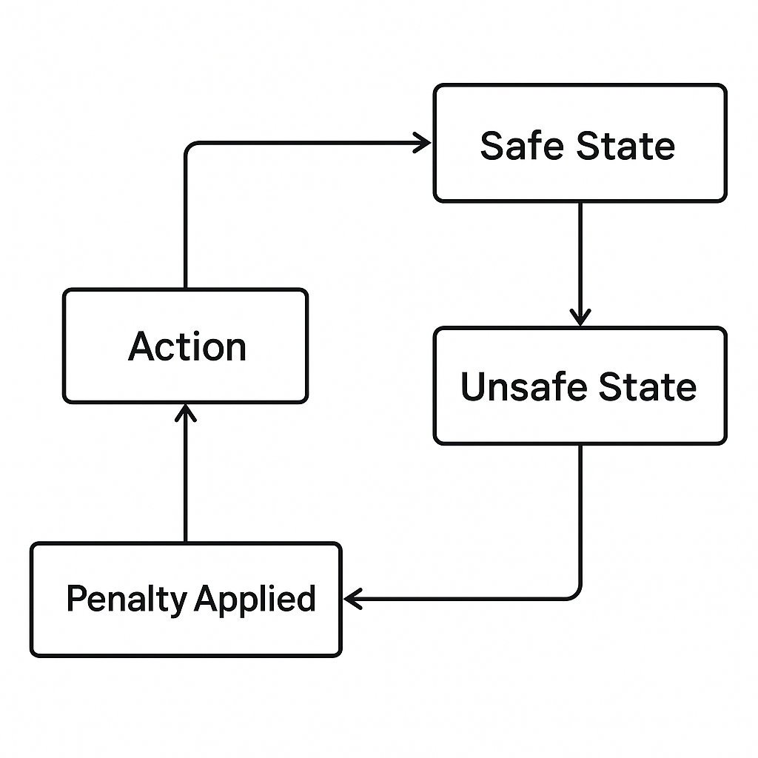

Figure 12 3 Comparison: DeepMind Lab vs. Unity ML-Agents.

The side-by-side diagram in *Figure 12.3* compares DeepMind Lab and Unity ML-Agents. DeepMind Lab is especially good at tasks involving 3D navigation and memory, while Unity ML-Agents supports multi-agent systems and sim-to-real workflows. Both platforms provide strong environments for training and testing intelligent agents.

**DeepMind Lab**:

* An immersive 3D platform for training AI agents in visually rich, interactive environments.
* Encourages research in navigation, memory, and problem-solving.

**Unity Machine Learning Agents (ML-Agents):**

* Integrates Unity’s game engine with reinforcement learning libraries.
* Supports multi-agent scenarios and sim-to-real applications.

****Applications and Trends****

The latest advancements in reinforcement learning extend far beyond traditional applications, employing innovative approaches to tackle complex problems. Emerging trends show how RL addresses meta-learning, sim-to-real transfer, and multi-agent systems. These advancements signal a shift toward developing intelligent agents that can adapt to diverse and unpredictable environments, bridging theoretical breakthroughs with practical, real-world applications.

* **Meta-Learning**: Enabling agents to generalize across tasks by learning adaptable policies.
* **Sim-to-Real Transfer**: Bridging the gap between simulation and real-world deployments.
* **Multi-Agent Systems**: Tackling cooperative and competitive dynamics in shared environments.

****Unity ML-Agents Integration****

**(Code Example)**

Unity Machine Learning Agents (ML-Agents) is a powerful framework that combines Unity's advanced game engine with reinforcement learning libraries. This integration enables researchers to create highly interactive environments, simulate complex behaviors, and develop intelligent agents that can handle multi-agent scenarios and bridge the gap between simulation and real-world applications. Below is a code example showing how to set up a simple environment using ML-Agents to train an agent in a Unity-based game.

`python

from mlagents_envs.environment import UnityEnvironment

from stable_baselines3 import PPO

# Initialize the Unity environment

unity_env_path = "path/to/your/Unity/environment" # Replace with the actual path to your Unity environment

env = UnityEnvironment(file_name=unity_env_path)

# Define the PPO agent

model = PPO("MlpPolicy", env, verbose=1)

# Train the agent

model.learn(total_timesteps=10000)

# Save the trained model

model.save("unity_agent_model")

# Test the trained agent

obs = env.reset()

while True:

action, _ = model.predict(obs, deterministic=True)

obs, reward, done, info = env.step(action)

if done:

obs = env.reset()

`

The code starts by importing necessary modules, including UnityEnvironment from mlagents_envs to connect with Unity-based environments and PPO from the stable_baselines3 library for implementing the reinforcement learning algorithm.

The Unity environment is set up using the UnityEnvironment class. Here, the file_name parameter indicates the path to the Unity environment file, which serves as the training ground for the agent. This environment could be as simple as a gridworld or as complex as a 3D scenario, depending on the simulation being modeled.

Next, a Proximal Policy Optimization (PPO) agent is set up using the stable_baselines3 library. PPO is selected for its balance between stability and performance in training reinforcement learning agents. The MlpPolicy specifies the use of a multilayer perceptron neural network for the policy architecture, while the verbose parameter allows detailed logging of the training process.

The training phase runs with the model.learn() method, which takes the total number of timesteps as a parameter. During this phase, the agent interacts with the environment to learn the best actions to maximize its overall reward.

Once training is complete, the model is saved using model.save(). This ensures the trained agent can be reloaded and tested without retraining.

The testing phase begins by resetting the environment with env.reset() and then allowing the agent to take actions in a loop. The model.predict() function determines the agent's actions based on the current state observations (obs). The environment responds with feedback, including the next state, reward, and a flag (done) indicating if the episode has ended. If the episode ends, the environment resets to allow further evaluation.

This example shows how Unity ML-Agents works with reinforcement learning frameworks to create, train, and test agents in dynamic and interactive environments. Such tools are essential for advancing artificial intelligence applications, from gaming to solving real-world problems.

****Ethical Considerations and Societal Impact****

As artificial intelligence technologies keep advancing, their integration into daily life raises important ethical and societal questions. Beyond technical progress, responsible development and use of AI require a commitment to principles that protect fairness, privacy, and accountability. This section examines these key ethical principles and explores the diverse societal roles of AI, emphasizing both the opportunities it provides and the challenges it introduces.

To contextualize ethical considerations in reinforcement learning, we introduce a conceptual hierarchy that outlines key values guiding the responsible development and deployment of AI systems.

Figure 12.4 Ethical Foundations and Societal Impact of AI

This layered diagram illustrates the ethical principles guiding AI’s impact on society. Fairness is the foundation, followed by transparency, accountability, and then the wider influence on society. This framework highlights how ethical principles support long-term trust, governance, and public benefit in AI development.

****Core Ethical Principles****

Ethical considerations lie at the heart of AI development, providing a moral compass to guide its applications and ensure they contribute positively to society. By addressing transparency, bias, and accountability, these principles lay the groundwork for creating AI systems that are both equitable and trustworthy [1].

* **Transparency**: AI systems must be interpretable, with decisions that are explainable to stakeholders. This principle becomes critical in high-stakes areas like healthcare and criminal justice, where opaque decision-making can lead to severe consequences [1] [2].
* **Bias Mitigation**: Addressing biases embedded in training datasets or algorithms is essential to prevent harm, particularly to vulnerable populations. For instance, research shows that biased AI systems can perpetuate inequality, such as in hiring or loan approvals [3].
* **Accountability**: Mechanisms for auditing AI behaviors and outcomes ensure that developers and organizations can be held responsible for unintended consequences. Accountability frameworks are especially critical in autonomous systems like self-driving cars or AI-driven medical diagnostics [2].

****AI’s Societal Role****

Artificial intelligence has become a transformative force across industries, revolutionizing the way tasks are performed and paving new paths for innovation. However, alongside these benefits, AI also introduces challenges that must be carefully managed to ensure its advantages are shared broadly and its risks kept in check.

**Opportunities**:

* Automation of repetitive tasks increases productivity and efficiency, freeing human workers to focus on more creative and strategic activities [4].
* Innovations in AI foster economic growth, spurring the development of new industries, such as personalized medicine and smart cities [5].

**Challenges**:

* Job displacement is a significant concern, particularly in sectors like manufacturing and customer service. Estimates suggest millions of jobs may be automated in the coming decade, creating the need for reskilling programs [6].
* The risks of surveillance and privacy erosion grow with AI-powered tools capable of mass data collection and analysis. Governments and corporations must implement stringent data protection measures to counterbalance these risks [7].

****Practical Tools for Ethical AI****

To ensure AI systems follow ethical principles, developers can utilize practical tools to assess their models for fairness, transparency, and accountability. These tools offer actionable insights on whether an AI system meets established guidelines and can identify areas for improvement. Below is an example of a Python function designed to evaluate a model's fairness by detecting bias in its predictions.

`python

def evaluate_ai_ethics(model, dataset):

# Check for fairness

predictions = model.predict(dataset)

bias_detected = np.std(predictions) > 0.1 # Example threshold

print("Bias Detected:", bias_detected)

`

This code snippet demonstrates a straightforward approach to evaluating the fairness of an AI model. The evaluate_ai_ethics function takes two inputs: model, representing the AI system being tested, and dataset, the data used to evaluate the model's predictions.

The function uses model.predict() to generate predictions on the dataset. It then measures the variability in these predictions by calculating the standard deviation np.std(predictions). A high deviation, exceeding a set threshold (such as 0.1), may indicate that the predictions are unevenly distributed, suggesting possible bias in the outputs.

Finally, the function indicates whether bias has been detected, providing a clear signal of the model's fairness. This tool serves as a fundamental step for developers to assess AI ethics, providing a quick and effective way to identify potential issues that could compromise the system's fairness or trustworthiness.

****Future Trends and Research Directions****

As reinforcement learning continues to advance, new trends and research areas are expanding their scope. From improving AI safety to developing energy-efficient methods, these innovations not only boost technical skills but also tackle urgent societal and environmental issues.

As reinforcement learning progresses into high-stakes settings, safe exploration becomes crucial. The diagram below illustrates how agents can distinguish between safe and unsafe results, modifying their actions accordingly.

Figure 12.5 Safe Exploration and Penalty Feedback in Reinforcement Learning

*Figure 12.5* illustrates the safe exploration loop in RL. The agent performs an action, which may lead to a safe or unsafe state. If the result is unsafe, a penalty is applied, and the agent adjusts its behavior to avoid similar risks. This framework facilitates risk-aware learning, a vital aspect when implementing AI in real-world systems.

****Exciting Frontiers****

The horizons of reinforcement learning are broadening into exciting new areas, driven by innovations in safety, sustainability, and generalization. These advances are poised to make AI systems more reliable, flexible, and impactful across a range of key applications.

* **Safe Reinforcement Learning** focuses on designing algorithms that prioritize safe exploration, minimizing risks in sensitive domains like healthcare and autonomous vehicles.
* **Energy-Efficient AI** addresses the environmental impact of training large-scale models by optimizing resource usage and reducing carbon footprints.
* **General AI** represents a bold leap toward systems capable of mastering diverse tasks without domain-specific tailoring, heralding a new era of versatility in AI.

****Safe Exploration in RL****

**(Example)**

In safety-critical environments, reinforcement learning must account for the risks associated with unsafe actions or states. This example demonstrates a practical approach to safe exploration, where the environment penalizes the agent for entering unsafe states, thereby encouraging safer learning behavior.

`python

class SafeEnvWrapper:

def __init__(self, env):

self.env = env

def step(self, action):

state, reward, done, info = self.env.step(action)

# Penalize unsafe states

reward -= 10 if self.is_unsafe(state) else 0

return state, reward, done, info

def is_unsafe(self, state):

# Define unsafe conditions

return state[0] < -1.0 or state[0] > 1.0

`

The SafeEnvWrapper class wraps a standard reinforcement learning environment (env) while adding safety constraints. This wrapper discourages agents from exploring unsafe states by penalizing their rewards.

* **Initialization:** The SafeEnvWrapper class takes an existing environment as input during initialization, making it compatible with any reinforcement learning environment.
* **Step Function:** The step method intercepts actions performed by the agent. After executing the action in the environment, the method checks if the resulting state violates predefined safety conditions. If the state is deemed unsafe, a penalty of 10 is subtracted from the agent’s reward, signaling that such behavior is undesirable.
* **Safety Conditions:** The is_unsafe method defines the criteria for unsafe states. In this example, any state where the first dimension exceeds the range [-1.0, 1.0] is flagged as unsafe. These conditions can be tailored to specific applications, enabling flexibility across different domains.

This approach is especially useful in applications where safety is critical. By adding such mechanisms into reinforcement learning environments, developers can train agents to follow safety constraints, ensuring strong and dependable performance in real-world situations. This example underscores the increasing importance of considering ethics and practicality in the design of AI systems.

****Chapter Conclusion****

As we conclude, it’s clear that reinforcement learning continues to lead the way in AI innovation. By revisiting core concepts, examining cutting-edge tools, and discussing the ethical implications of AI, this chapter underscores the importance of striking a balance between technological advancements and social responsibility.

To conclude this exploration, in *Figure 12.6* we present a forward-looking roadmap that outlines the evolving trajectory of reinforcement learning, from foundational techniques to more complex and ethically aligned systems.

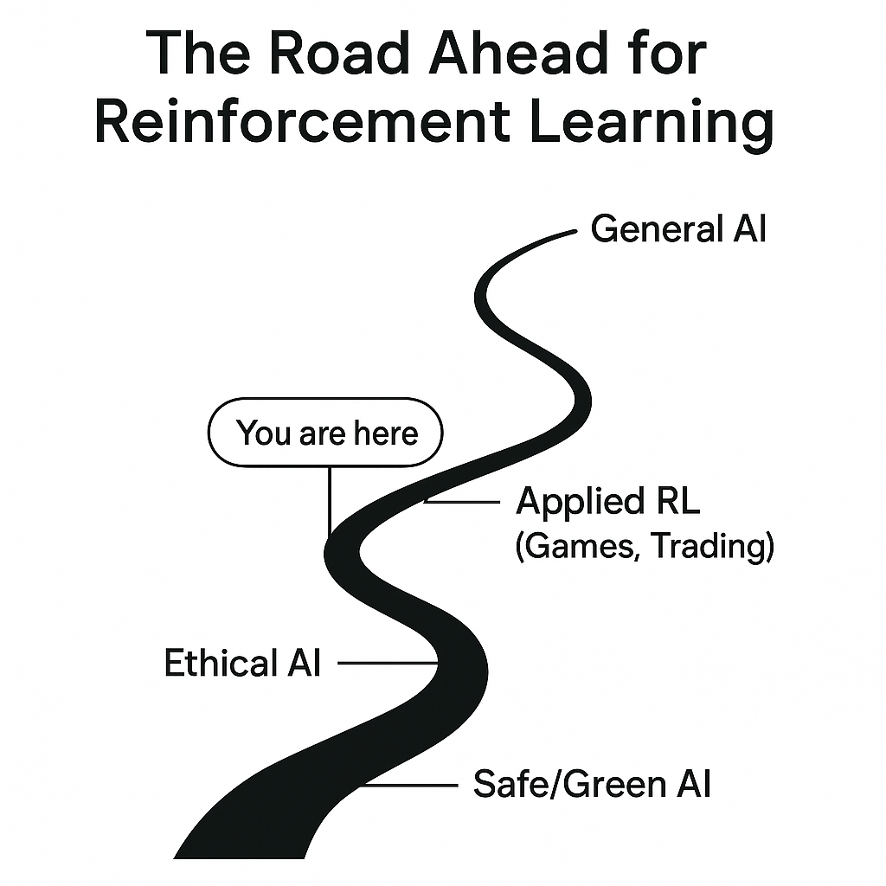

Figure 12. 6 The Road Ahead for Reinforcement Learning.

This diagram shows the future development of reinforcement learning. It begins with basic RL ideas, moves through practical areas such as gaming and trading, and aims for ethical and sustainable AI, ultimately culminating in the goal of achieving general intelligence. The “You are here” marker indicates the current stage of the field and encourages readers to imagine their next steps.

****Book Conclusion****

As we wrap up this comprehensive journey, it's time to reflect on how far we've come. This conclusion brings together the main themes and insights of the book, providing a final view on the transformative power of reinforcement learning and artificial intelligence.

****Key Takeaways****

In summarizing the core lessons of this book, the main takeaways act as a guide to understanding the fundamental concepts, practical implications, and ethical responsibilities that form the basis of reinforcement learning. These insights capture the essence of what has been discussed, offering a clear understanding of AI’s role in shaping the future.

* **Core Concepts**: Understanding reinforcement learning principles is crucial for designing robust AI systems.
* **Practical Applications**: From mastering games to optimizing logistics, reinforcement learning has proven its versatility.
* **Ethical AI**: As AI continues to integrate into daily life, ethical considerations must guide its development.

****Vision for the Future****

This book lays the foundation for navigating the vast and constantly changing world of artificial intelligence. As AI continues to reshape what is possible, it encourages us to not only accept its capabilities but also to share responsibility in guiding its development. Readers are urged to approach AI with curiosity and critical thinking, promoting innovation that tackles real-world problems while being mindful of its societal effects. By working toward fair access, ethical use, and transformative solutions, we can collectively realize AI's potential to build a smarter, more inclusive, and interconnected world where technology acts as a tool for progress and empowerment.

****Closing Remarks****

The road ahead is full of opportunities and challenges, offering endless potential for discovery and growth. With the knowledge, practical insights, and ethical awareness gained from this book, you are well-equipped to make meaningful contributions to the field of artificial intelligence. Whether by advancing research, creating innovative applications, or promoting responsible AI practices, your efforts will influence the future of this discipline. As we look ahead, let’s stay dedicated to using AI not only for innovation but also to build a fairer, more sustainable world enriched by the limitless creativity of human and machine collaboration.

References

|  |  |
| --- | --- |
| [1] | F. Doshi-Velez and B. Kim, "Towards a rigorous science of interpretable machine learning," 2017. |
| [2] | L. Floridi, "AI4People - An ethical framework for a good AI society: Opportunities, risks, principles, and recommendations," *Minds and Machines,* vol. 28, pp. 689, 707, 2018. |
| [3] | C. O'Neil, Weapons of math destruction: How big data increases inequality and threatens democracy, Crown Publishing Group, 2016. |
| [4] | E. Brynjolfsson and A. McAfee, The second machine age: Work, progress, and prosperity in a time of brilliant technologies, W.W. Norton and Company, 2014. |
| [5] | S. Russell and P. Norvig, Artificial Intelligence: A modern approach, Fourth edition ed., Pearson, 2020. |
| [6] | C. B. Frey and M. A. Osborne, "The future of employment: How susceptible are jobs to computerisation?," *Technological Forecasting and Social Change,* vol. 114, pp. 254, 280, 2017. |
| [7] | S. Zuboff, The age of surveillance capitalism: The fight for a human future at the new frontier of power, PublicAffairs, 2019. |